

Species Summaries for the Southern and Eastern Scalefish and Shark Fishery
  - For stock assessments completed in 2016 in preparation for the 2017-18 fishing season

Contents
Contents 2
Introduction 3
1 Blue eye trevalla (Hyperoglyphe antarctica) 4
2 Blue warehou (Seriolella brama) 9
3 Deepwater flathead (Platycephalus conatus) 14
4 Tiger Flathead (Platycephalus richardsoni) 19
5 Eastern gemfish (Rexea solandri) 25
6 Western Gemfish (Rexea solandri) 30
7 Gummy shark (Mustelus antarcticus) 36
8 Mirror dory (Zenopsis nebulosus) 43
9 Redfish (Centroberyx affinis) 49
10 School shark (Galeorhinus galeus) 55

Introduction
These species summaries provide information on quota species assessed by Southern and Eastern Scalefish and Shark Fishery (SESSF) Resource Assessment Groups (RAGs): Great Australian Bight RAG (GABRAG); South East RAG (SERAG) and SharkRAG. These assessment summaries apply to stock assessments completed in 2016 in preparation for the 2017-18 fishing season.

The summaries contain basic information on stock status, Total Allowable Catches (TACs) and catch trends, assessment details and RAG comments. The summaries are designed to be a quick reference, and should be read in conjunction with RAG minutes and the applicable species stock assessments. Annual updates are completed for species that have a new stock assessment, were considered by the RAGs or species that are under AFMA rebuilding strategies. The most recent full set of species summaries can be found on the AFMA website.

A glossary of commonly used terms is available at the end of the document.

  - Blue eye trevalla (Hyperoglyphe antarctica)
ABARES (2012): Line drawing - FAO

Assessed by South East RAG in 2016. Species summary updated in 2016.

Stock status summary
Stock structure | Blue-Eye trevalla (Hyperoglyphe antarctica) is managed as a single stock. A report on stock structure will be available later in 2016 which indicates there is stock structuring.
Stock status against reference points and trend | Tier 4 species use CPUE targets as a proxy of biomass targets.  The Tier 4 target reference point is the level of CPUE assumed to be a proxy for spawning biomass of 48 per cent of unfished levels. The limit reference point is the equivalent CPUE that acts as a proxy for 20 per cent of unfished levels.  In 2015 SlopeRAG agreed to use a revised catch per hook metric in the Tier 4 analysis in place of the previously used catch per record/day. The RAG considered the updated analysis to be a better reflection of CPUE in the early part of the fishery.  A Tier 4 assessment was considered at SERAG in 2016 using updated dropline and automatic longline CPUE information.
  CPUE
  Ref year | 1997-2006
  Target | 1.0660
  Limit | 0.4442
  Recent | 0.9230
ABARES most recent assessment (2016) | Biomass: Not overfished | Fishing mortality: Not subject to overfishing
GVP figures  (2014-15 fishing season) | GVP | % fishery GVP
GVP figures  (2014-15 fishing season) | $2.4 million | 3.5%
Recommended Biological Catch 2017 - 18 | 526 t
Overcatch/undercatch | 10 per cent undercatch  10 per cent overcatch
Probability of recommended biological catch (RBC) (or other levels of catch) causing a decline below limit reference under proposed management  Species that follow a HS rule that has been MSE tested will have a “very unlikely” score in this section (i.e. P<10 %). | Tier 4 assessments do not assess the probability of being below the reference point. However, the RAG considers the current assessment to be conservative.  The RBC is taken from the MSE-tested harvest control rules. If the standardised CPUE series is a reasonable index of relative abundance the RBC will have a very low probability of causing a decline below the limit reference point.
 | Alternative Catch Scenarios: N/A (Tier 4)

Assessment Year | 2010 | 2011 | 2012 | 2013 | 2014 | 2015 | 2016
Tier /rollover /MYTAC | Tier 4 | Tier 4 | Rollover | Tier 4 | MYTAC | Tier 4 | Tier 4
Stock Status | CPUE between target and limit | CPUE between target and limit | Not assessed | CPUE between target and limit | MYTAC | CPUE between target and limit | CPUE between target and limit
Fishing Year | 2011/12 | 2012/13 | 2013/14 | 2014/15 | 2015/16 | 2016/17 | 2017/18
RBC(t) | 521 | 415 | N/A TAC rolled over | 269 | 269* | 444 | 526
Agreed TAC | 326 | 387 | 388 | 335 | 335 | 410
Actual TAC after overs/unders | 361 | 385 | 417 | 355 | 363 | 430
% TAC caught | 98 | 86 | 85 | 76 | 82

Tier Level & Discounts
Tier Level | Tier 4- for details of Tiers and the Harvest Strategy, see: http://www.afma.gov.au
Discount factor | 0 per cent. The RAG recommended that the discount factor not be applied due to the conservative estimate of the RBC (due in part to unaccounted orca predation) and protection afforded the stock by fishing closures.
Is a multi-year TAC in place? | ☐Yes (in place this season) | ☒No
Is a multi-year TAC recommended?  (please provide a clear indication on whether the multi-year recommendation is a RBC (e.g. based on Tier 1 model output) or TAC (e.g. a roll-over of catch)) | ☐Yes (recommended for future seasons) | ☒No  The RAG did not support more than a single year TAC because a report on stock structure will be available in 2017 and this may inform assumptions used in the assessment.
Breakout rules for multi-year TAC | N/A
Have breakout rules been triggered? | N/A

Assessment
Stock indicator trends | Total blue eye trevalla catches have declined from 650 t in 2006 to between 270 and 315 t for the last three years.  There has been a general increase in CPUE over the last four years, with the CPUE above the target in 2014, and decreasing below the target again in 2015.
RAG comments | In 2015 the RAG agreed to use the catch per hook metric, noting that this is a better reflection of CPUE across the fishery. The updated analysis resulted in a lower CPUE in the early part of the data series, confirming that the 2014 Tier 4 assessment was conservative in nature and that blue eye trevalla are less depleted than the assessment indicated.  In 2016, Alan Williams and Malcolm Haddon presented a draft report on their work investigating blue-eye trevalla stock structure. The project is funded by AFMA and FRDC. SERAG will consider the report in 2017.
Key model technical assumptions/parameters | - CPUE from zones 20 to 50 is assumed to be proportional to abundance.  - The best assessment is obtained by using catch per hook as the effort metric for CPUE.  - The target reference period provides an acceptable CPUE proxy for the target reference point.  - Total catch history is accurate.
Changes to model structure/assumptions | See above
Significant changes to data inputs | See above
Comments on data | In 2016 that RAG noted that significant areas were closed to the fishery but analysis of the standardised CPUE showed there was limited impact on the CPUE series.
Implications for companion species/TEPs/multi-species fisheries | Auto longline operators catch pink ling and blue eye trevalla; there is potential for increased incidental ling catches due to an increase in blue eye trevalla RBC.

Tier 4 CPUE series
Projected biomass (include confidence intervals) | 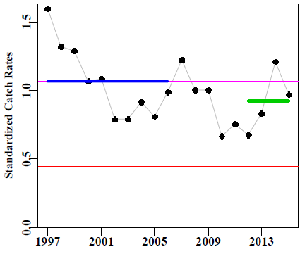  Standardised Blue eye Trevalla catch rates (Haddon 2016) combined dropline and longline catch-per-hook. The upper fine line represents the target catch rate and the lower line the limit catch rate. Thickened lines represents the reference period for catches, catch rates, and the recent average catch rate.

Research
Research allowance | 0 t from the 2016 FIS
Research allowance | ☒Included in TAC |  | ☐In addition to TAC

Catch trends – Blue eye trevalla
(RBC and total catch are calendar year; TAC and Commonwealth catch are fishing season)
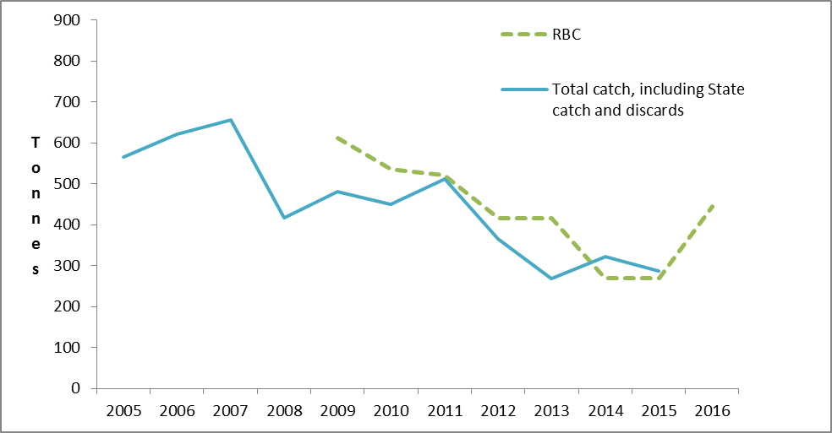

  - Blue warehou (Seriolella brama)

ABARES (2012): Line Drawing – Rosalind Poole

Common names: Black trevally, sea bream, snotty trevalla.

Under a Stock Rebuilding Strategy.

Last accepted Tier 1 assessment in 2006. Assessed by ShelfRAG in 2013. Species summary updated in 2016.

Stock status summary
Stock structure | There is good evidence that there are two stocks of blue warehou, east and west of the Bass Strait, but the species is managed under a single TAC.
Stock status against reference points and trend | Tier 4 species use CPUE targets as a proxy of biomass targets.  The Tier 4 target reference point is the level of CPUE assumed to be a proxy for spawning biomass of 48 per cent of unfished levels. The limit reference point is the equivalent CPUE that acts as a proxy for 20 per cent of unfished levels.  2013 Stock status: In 2013 blue warehou was expected to be below the limit reference point and is subject to a rebuilding strategy. The last agreed Tier 1 assessment in 2005-06 found the eastern stock to be depleted below the limit reference point. In contrast, the western stock was thought to be above the limit reference point and close to the biomass maximum sustainable yield (B₄₀) level. However, the assessment predicted that the western stock will have dropped below the limit reference point by 2007 if the landed catches remained high and if recruitment was average.  Biomass trend: The standardised CPUE for both stocks continue to be low and declining in 2015, however, due to avoidance of blue warehou by operators the use of CPUE as an index of abundance is no longer considered reliable.  Catches have been low over the last few years and below the incidental TAC, particularly in 2015 with only 4.5 t landed. As a consequence of low catches there is little data.
  CPUE | East | West
  Target | 2.0717 | 1.9249
  Limit | 0.8287 | 0.7699
  Recent | 0.1861 | 0.2681
ABARES most recent assessment (2016) | Biomass: Overfished | Fishing mortality: Uncertain
GVP figures  (2014 – 15 fishing season) | GVP | % fishery GVP
GVP figures  (2014 – 15 fishing season) | <$0.1 million | <0.15 per cent
Recommended Biological Catch 2017 - 18 | 0 t – RBCs for both eastern and western stocks remain at zero as standardised catch rates are below the limit reference points.  Blue warehou is managed under the Blue Warehou Stock Rebuilding Strategy.  The Blue Warehou Stock Rebuilding Strategy was updated in 2014 and is available here.  An incidental catch TAC of 118t is recommended by SERAG.
Overcatch/undercatch | 0 per cent undercatch  0 per cent overcatch
Probability of recommended biological catch (RBC) (or other levels of catch) causing a decline below limit reference under proposed management  Species that follow a HS rule that has been MSE tested will have a “very unlikely” score in this section (i.e. P<10 %). | N/A – Already considered to be below the limit reference point.
 | Alternative Catch Scenarios: N/A – Already considered to be below the limit reference point.

Assessment Year | 2010 | 2011 | 2012 | 2013 | 2014 | 2015 | 2016
Tier /rollover /MYTAC | Tier 4 | Tier 4 | Tier 4 | Tier 4 | Not assessed | Not assessed | Not assessed
Stock Status | E: CPUE less than limit  W: CPUE less than limit | E: CPUE less than limit  W: CPUE less than limit | E: CPUE less than limit  W: CPUE less than limit | E: CPUE less than limit  W: CPUE less than limit | E: CPUE less than limit  W: CPUE less than limit | E: CPUE less than limit  W: CPUE less than limit | E: CPUE less than limit  W: CPUE less than limit
Fishing Year | 2011/12 | 2012/13 | 2013/14 | 2014/15 | 2015/16 | 2016/17 | 2017/18
RBC (t) | 0 | 0 | 0 | 0 | 0 | 0 | 0
Agreed TAC | 133 | 118 | 118 | 118 | 118 | 118 | 118
Actual TAC (t) after overs/unders | 133 | 118 | 118 | 118 | 118 | 118 | 118
% TAC caught | 73 | 41 | 55 | 14 | 2

Tier Level & Discounts
Tier Level | Tier 4- for details of Tiers and the Harvest Strategy, see: http://www.afma.gov.au
Discount factor | N/A (incidental catch TAC)
Is a multi-year TAC in place? | ☐Yes (in place this season) | ☒No
Is a multi-year TAC recommended? | ☐Yes | ☒No
Breakout rules for multi-year TAC | N/A
Have breakout rules been triggered? | N/A

Assessment
Stock indicator trends | The RAG noted again its’ concern that CPUE is not a good index of abundance while there is an incidental catch TAC in place and industry is actively avoiding the species. An alternative primary index of abundance needs to be developed as a high priority for use in future stock assessments.  The RAG noted low catches of blue warehou in 2015 and that the geographic range of catches has contracted.  There was no information available to the RAG to suggest that the stock was recovering; the RAG noted the importance of the planned project looking at declining and non-recovering stocks.

Key model technical assumptions/parameters | N/A
Changes to model structure/assumptions | N/A
Significant changes to data inputs | N/A
Comments on data | N/A
Implications for companion species/TEPs/multi-species fisheries | N/A

Tier 4 CPUE series
Standardized Catch Rates, N.B. Tier 4 not updated in 2016 | Blue warehou (east left, west right) standardized catch rates with the upper fine line representing the target catch rate and the lower line the limit catch rate. Thickened lines represents the reference period for catches, catch rates, and the recent average catch rate.

Research
Research allowance | 0 t
Research allowance | ☐Included in TAC |  | ☐In addition to TAC

Catch trends – Blue warehou
(RBC and total catch are calendar year; TAC and Commonwealth catch are fishing season)
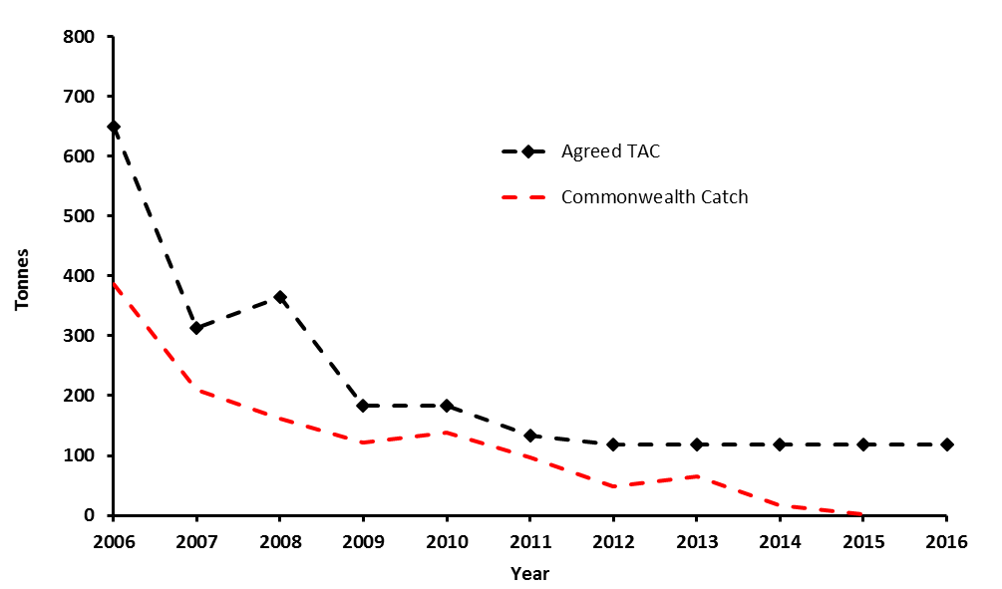

  - Deepwater flathead (Platycephalus conatus)

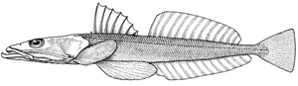

Obsolete common names: deep sea flathead, trawl flathead.
Assessed by GABRAG in 2016 Species summary updated in 2016.
Stock status summary
Stock structure | Assessed as a single stock.
Stock status against reference points and trend | Reference point is 20 per cent of unfished biomass.  Target is 43 per cent of unfished biomass.  2016: 45 per cent of unfished biomass.  The stock remains above the target.
ABARES most recent assessment (2016) | Biomass: Not overfished | Fishing mortality: Not subject to overfishing
GVP figures  (2015-16 fishing season) | GVP | % fishery GVP
GVP figures  (2015-16 fishing season) | $4.2 million | 6% (49% of GABTF)
Recommended Biological Catch 2017-18 | One year: 1155 tonnes.  Three year: 1128 tonnes  Five year: 1115 tonnes
Overcatch/undercatch | - 10% undercatch  - 10% overcatch
Probability of recommended biological catch (RBC) (or other levels of catch) causing a decline below limit reference under proposed management  Species that follow a HS rule that has been MSE tested will have a “very unlikely” score in this section (i.e. P<10%). | RBC recommendation = <10% (Very Unlikely)
 | Alternative Catch Scenarios = N/A

TAC and catch trends
Assessment Year | 2011 | 2012 | 2013 | 2014 | 2015 | 2016
Tier /rollover /MYTAC | Tier 1 | Tier 1 | Tier 1 | Multi year TAC | Multi year TAC | Tier 1
Stock Status (% of unfished biomass) | 33% | 39% | 45% | Not assessed | Not assessed | 45%
Fishing Year | 2012/13 | 2013/14 | 2014/15 | 2015/16 | 2016/17 | 2017/18
RBC | 1733 | 979 | 1146 | 1112 | 1112 | 1128
Agreed TAC | 1560 | 1150 | 1150 | 1150 | 1150
Actual TAC after overs/unders | 1723 | 1301 | 1264 | 1265 | 1256
% TAC caught | 55 | 68 | 52 | 50

Tier Level & Discounts
Tier Level | Tier 1- for details of Tiers and the Harvest Strategy, see: http://www.afma.gov.au
Discount factor | 0 %
Is a multi-year TAC in place? | ☒Yes (in place this season)  2016-17 is the final year of the multi-year TAC. | ☐No
Is a multi-year TAC recommended?  (please provide a clear indication on whether the multi-year recommendation is a RBC (e.g. based on Tier 1 model output) or TAC (e.g. a roll-over of catch)) | ☒Yes (recommended for future seasons)  Three year: 1128 t  Five year: 1115 t | ☐No
Breakout rules for multi-year TAC | - Observed standardized CPUE or FIS (when run) falls outside the 95 per cent confidence intervals projected from the assessment.
Have breakout rules been triggered? | N/A

Assessment
Stock indicator trends | While remaining above target, estimated spawning biomass suggests a gradual decline toward the target since 2012-13.  The spread of ages in recent age data indicates the stock is responding to a reduction in fishing effort.
RAG comments | The upturn in estimated spawning biomass following the reduction in catches from 2009-10 is driven by reduced fishing pressure and not by greater recruitment.  The RAG noted that catches are currently below RBC and the stock biomass is estimated to be above target.
Key model technical assumptions/parameters | The model projections assume average recruitment. However, recruitment estimates for recent years have been below average.
Changes to model structure/assumptions | The latest version of stock synthesis 3 software (SS3.24z) was applied.
Significant changes to data inputs | ISMP data were divided into the onboard and port based samples. Length and age composition data from the FIS and industry collected length composition were included for the first time.  There were large numbers of new samples, for example the industry collected length frequency samples alone contribute more than 35 000 extra records.
Comments on data | The RAG noted the 2015 FIS survey index is within bounds of variability of the commercial catch rate index. While the FIS survey index and commercial catch rates were unusually low over the same two months, which may be related to the substantial seismic survey being conducted over the same period, the RAG did not consider there was sufficiently strong basis for excluding the 2015 FIS catch rate data from the assessment.  Danish seine catch are included in the assessment but no additional data (age/length) from this fleet are available. The RAG recommended that AFMA observers undertake a Danish seine trip, focusing on length data. At its December meeting the RAG was pleased to note that one trip had recently been observed.  The RAG noted that it would be useful to undertake a meta-analysis to better understand the value for natural mortality in the assessment.
Implications for companion species/TEPs/multi-species fisheries | The RAG noted that deepwater flathead effort contributes to catches of other commercial species in the GAB.

Tier 1 stock projection
Projected biomass | 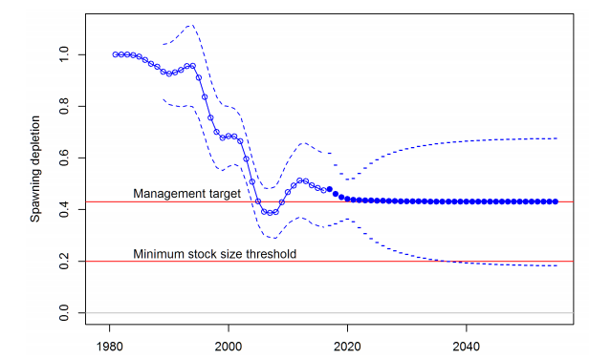  The 40 year projection depends on the RBC being caught each year, which, given recent catches, the RAG noted was unlikely due to the low number of vessels operating.

Research
Research allowance | N/A
Research allowance | ☐Included in TAC |  | ☐In addition to TAC

Catch trends

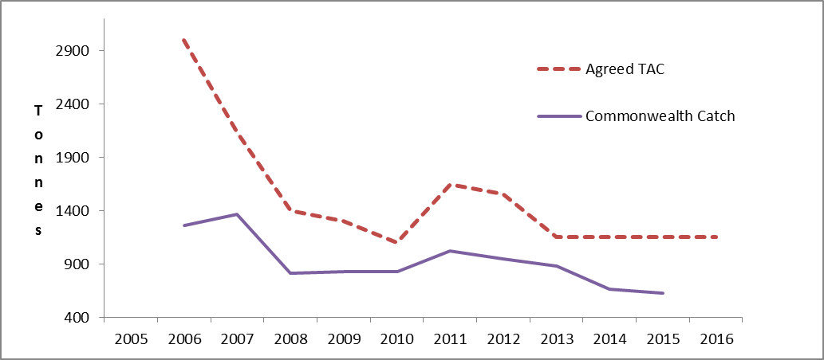

  - Tiger Flathead (Platycephalus richardsoni)
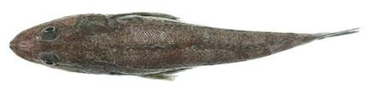

Common names: Deep sea flathead, flathead, king flathead, spiky flathead, trawl flathead.
Assessed by South East RAG in 2016. Species summary updated in 2016.
Stock status summary
Stock structure | For management purposes a single continuous stock has been assumed throughout all zones of the SESSF.
Stock status against reference points and trend | Limit Reference Point is 20 per cent of estimated unfished female spawning biomass  Target reference point is 40 per cent of estimated unfished female spawning biomass.  Trend: The last assessment in 2013 estimated the spawning biomass at 50 per cent of unexploited stock biomass. The 2016 assessment estimates the stock has fluctuated around 40 per cent of unexploited stock biomass since around 1990 with a slight increase in the last few years.  Stock status: The 2016 assessment estimated current spawning stock biomass as 42 per cent of unexploited stock biomass.
ABARES most recent assessment (2016) | Biomass: Not overfished | Fishing mortality: Not subject to overfishing
GVP figures  (2014-15 fishing season) | GVP | % fishery GVP
GVP figures  (2014-15 fishing season) | $15.4 million | 22.6 per cent
Recommended Biological Catch 2017-18 | Single year RBCs  2017: 2,886  2018: 2,865  2019: 2,848  2020: 2,834  2021: 2,823 |  | Multi-year RBCs  1 year: 2 886t  3 year: 2 866t  5 year: 2 851t
Overcatch/undercatch | - 10% undercatch  - 10% overcatch
Probability of recommended biological catch (RBC) (or other levels of catch) causing a decline below limit reference under proposed management  Species that follow a HS rule that has been MSE tested will have a “very unlikely” score in this section (i.e. P<10%). | Very unlikely (P<10%)
Alternative Catch Scenarios
On 12 January 2017 SERAG considered the biological implications to the flathead stock of adopting the following phased approaches to reducing the TAC over time:
- A 50 per cent cut in the proposed reduction in TAC for 2017-18, with the view to updating the assessment in 2017.
- A 50 per cent cut in the proposed reduction in TAC for 2017-18, with the remaining 50 per cent to be deducted in 2018-19 with the view to updating the assessment in 2018.
- A 33.3 per cent cut in the proposed reduction in TAC each year over three years with the view to updating the assessment in 2019.
For all options, the estimated spawning biomass depletion is at or above the target reference point of 40 per cent of virgin spawning biomass over the next five years as is consistent with objectives of the SESSF Harvest Strategy.

TAC and catch trends
Assessment Year | 2011 | 2012 | 2013 | 2014 | 2015 | 2016
Tier /rollover /MYTAC | MYTAC | MYTAC | Tier 1 | MYTAC | MYTAC | Tier 1
Stock Status | Not assessed | Not assessed | 50% | Not assessed | Not assessed | 42%
Fishing Year | 2012/13 | 2013/14 | 2014/15 | 2015/16 | 2016/17 | 2017/18
RBC (t) | Not assessed | Not assessed | 1 year: 3428 t  3 year: 3334 t  5 year: 3252 t | 3334 | 3334 | 1 year:  2886 t
Agreed TAC | 2741 | 2750 | 2878 | 2860 | 2882
Actual TAC after overs/unders | 2837 | 2835 | 3143 | 3092 | 2992
% TAC caught | 95 | 81 | 90 | 94

Tier Level & Discounts
Tier Level | Tier 1- for details of Tiers and the Harvest Strategy, see: http://www.afma.gov.au
Discount factor | N/A
Is a multi-year TAC in place? | ☒Yes (in place this season) | ☐No
Is a multi-year TAC recommended?  (please provide a clear indication on whether the multi-year recommendation is a RBC (e.g. based on Tier 1 model output) or TAC (e.g. a roll-over of catch)) | ☐Yes (recommended for future seasons) | ☒No  The RAG has recommended a single year RBC until the stock assessment has been updated. See RAG comments section below.
  Year | RBC
  2017 | 2,886 t
  2018 | 2,865 t
  2019 | 2,848 t
  2020 | 2,834 t
  2021 | 2,823 t
Breakout rules for multi-year TAC | The RAG suggested that if a MYTAC is adopted in the future the following breakout rules would be appropriate:  - Observed standardized CPUE falls outside the 95 per cent confidence intervals projected from the assessment.  - Observed total mortality differs from the projected mortality by +\-20 per cent.
Have breakout rules been triggered? | - N/A. Assessment year.
Assessment

Stock indicator trends | Refer to Tier 1 assessment.
RAG comments | November 2016 SERAG meeting  - The 2016 model outputs are robust to a range of sensitivities.  - The assessment indicated there has been better than average recent recruitments.  - The RBC has been reduced (approx. 15 per cent) because:  - 2013 model over estimated recent recruitment  - The 2013 assessment estimated biomass at 50 per cent, which has been fished down towards the target.  - Flathead are a key economic species, and there are implications for fishery GVP in reducing the RBC.  12 January 2017 SERAG teleconference:  - Corrections made to the assessment with adjusted RBCs as described above.  - Industry raised concerns over Danish seine gear selectivity estimates not being included in the model and requested a phased approach in reducing TAC until the assessment is updated.  - The RAG considered modeled projections under adjusted RBCs (to allow for higher TACs) which result in a biomass above target (B₄₀) over five years.  - The RAG has recommended a single year RBC for 2017-18 and the assessment to be updated in 2017. If the assessment is not completed in 2017, 2nd year RBCs have been calculated which are dependent on the TAC set by SEMAC.  - A Danish seine gear survey should be conducted to inform the 2017 assessment.
Key model technical assumptions/parameters | - The current assessment assumes a single growth curve for the whole stock, an assumption also made in previous assessments
Changes to model structure/assumptions | - The FIS treated as two separate fleets to account for spatial differences in length frequencies.  - The weighting of length frequency data by shot or trip numbers rather than numbers of fish measured  - Modifications to the tuning procedures including use of Francis weighting for length and age data
Significant changes to data inputs | - Both port and onboard length frequency data were included.  - Length frequency data from the fishery independent surveys from 2008, 2010, 2012 and 2014 was included.
Comments on data | - Conduct gear survey to identify changes to Danish seine gear mesh sizes  - Need to investigate spatial differences in growth parameters between eastern TAS and other regions
Implications for companion species/TEPs/multi-species fisheries | - Flathead are a key economic species, and there are implications for fishery GVP in reducing the RBC.

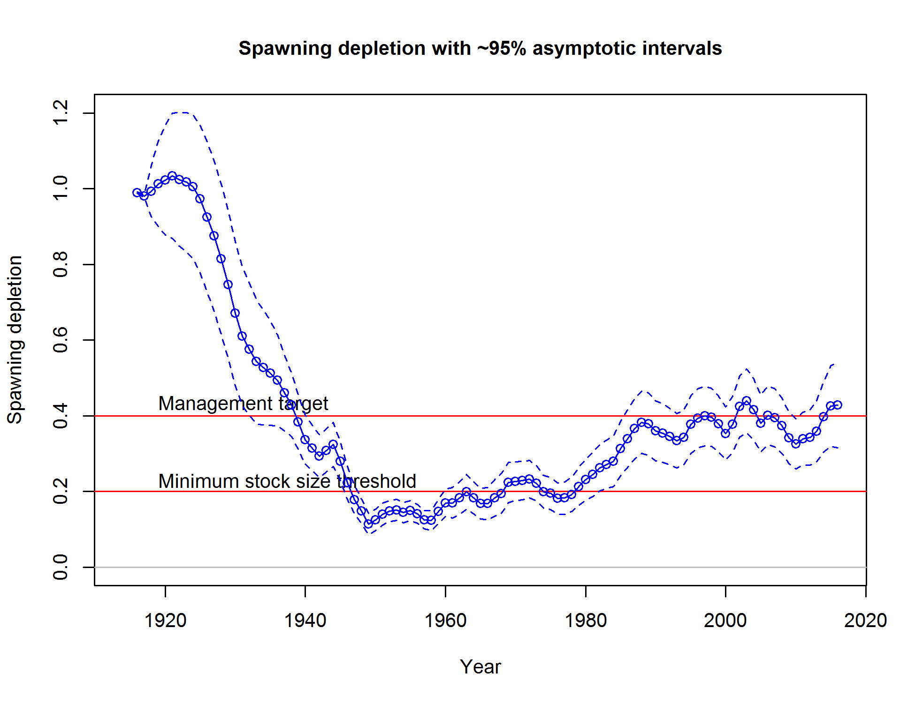
Research
Research allowance | 10 t from 2016 FIS
Research allowance | ☒Included in TAC |  | ☐In addition to TAC

Catch trends

The 2015-16 agreed TAC was exceeded due to application of overcatch provisions.
  - Eastern gemfish (Rexea solandri)

Common names: Gemfish, silver gemfish and king couta.

Under a Stock Rebuilding Strategy.

Assessed by ShelfRAG in 2010. Species summary updated in 2016.

Stock status summary
Stock structure | There are considered to be two stocks of R. solandri in Australia, an eastern and a western stock bordered by a boundary in the south west of Tasmania (west of 146°22’E, north of 42°43’S).  The current assessment is based solely on eastern gemfish, caught south of Latitude 43° south off western Tasmania, and east of longitude 146° 22`.
Stock status against reference points and trend | Limit reference point is 20 per cent of unfished biomass.  Target reference point is 48 per cent of unfished biomass.  Stock status: The last updated assessment in 2009 (updated from 2008), assessed eastern gemfish to be at 16 per cent of its unfished biomass, and hence to be below the limit reference point.  The Eastern gemfish Stock Rebuilding Strategy has been updated and was released in early 2015. The current rebuilding strategy is located here.  Biomass trend: While a revised assessment was not undertaken, the 2008 assessment model was updated with more recent data. The updated assessment was not accepted by the RAG, however, the RAG noted that the outcome did not provide any evidence of stock rebuilding.
ABARES most recent assessment (2016) | Biomass: Overfished | Fishing mortality: Uncertain
GVP figures  (2014 - 15 fishing season) | GVP | % fishery GVP
GVP figures  (2014 - 15 fishing season) | <$0.1 million | <0.15 per cent
Recommended Biological Catch 2017-18 | 0 t (under a bycatch TAC)  Incidental total allowable catch of 100 t
Overcatch/undercatch | 0 per cent undercatch  0 per cent overcatch
Probability of recommended biological catch (RBC) (or other levels of catch) causing a decline below limit reference under proposed management  Species that follow a HS rule that has been MSE tested will have a “very unlikely” score in this section (i.e. P<10 %). | RBC recommendation – N/A, already considered to be below the limit reference point.
 | Alternative Catch Scenarios: N/A

Assessment Year | 2010 | 2011 | 2012 | 2013 | 2014 | 2015 | 2016
Tier /rollover /MYTAC | Tier 1 | Not assessed | Not assessed | Not assessed | Not assessed | Not assessed | Not assessed
Stock Status | 16 | Not assessed | Not assessed | Not assessed | Not assessed | Not assessed | Not assessed
Fishing Year | 2011/12 | 2012/13 | 2013/14 | 2014/15 | 2015/16 | 2016/17 | 2017/18
RBC | 0 | 0 | 0 | 0 | 0 | 0 | 0
Agreed TAC | 100 | 100 | 100 | 100 | 100 | 100
Actual TAC after overs/unders | 100 | 100 | 100 | 100 | 100 | 100
% TAC caught | 77 | 63 | 52 | 37 | 30

Tier Level & Discounts
Tier Level | Tier 1 (last full assessment in 2009) - for details of Tiers and the Harvest Strategy, see: http://www.afma.gov.au
Discount factor | 0 per cent
Is a multi-year TAC in place? | ☐Yes (in place this season) | ☒No
Is a multi-year TAC recommended?  (please provide a clear indication on whether the multi-year recommendation is a RBC (e.g. based on Tier 1 model output) or TAC (e.g. a roll-over of catch)) | ☐Yes (recommended for future seasons) | ☒No

Breakout rules for multi-year TAC | Observed standardised CPUE falls outside of 95 per cent confidence interval of that predicted by the Tier 1 assessment.  Aggregated catch and discards exceed 100t.
Have breakout rules been triggered? | N/A

Assessment
Stock indicator trends | Landed catches remain well below the incidental catch TAC and have been declining  Aggregated landings and discards are less than the TAC and declining
RAG comments | The RAG reviewed the 2015 calendar year data and noted:  - discard rates remain high at between 40-60 per cent  - the non-targeted spawning standardized CPUE has decreased  - there has been low recruitment since 2002 and biomass is tracking down since that 2002 cohort entered the fishery  Projections from the most recent assessment, updated during 2010, indicate that with average recruitment the stock would recover within 13 years which is within the rebuilding timeframe specified in the HSP.  CSIRO reviewed the available data for eastern gemfish in August 2016 and prepared a preliminary update of the eastern gemfish assessment, in order for the SESSFRAG to provide advice on whether an assessment is completed in 2016 or deferred to 2017.  The RAG recommended that an assessment be postponed until 2017 and that the data should be assessed during 2017 to determine whether an updated assessment would inform stock status.  The RAG has previously pointed out the eastern gemfish stock may now be at a new equilibrium and the stock may not rebuild under current conditions meaning the Eastern Gemfish Rebuilding Strategy under the Harvest Strategy Policy may not achieve its objectives. The RAG noted the importance of the planned project looking at declining and non-recovering stocks.  The RAG agreed that continuing with the 100t incidental catch MYTAC was appropriate.
Key model technical assumptions/parameters | N/A
Changes to model structure/assumptions | N/A
Significant changes to data inputs | N/A
Comments on data | N/A
Implications for companion species/TEPs/multi-species fisheries | Historically there were reports of a companion species relationship between mirror dory and eastern gemfish which is likely to have changed due to avoidance of fishing the areas and depths that these species inhabit during the eastern gemfish spawning season.

Tier 1 stock projection
Projected biomass (include confidence intervals) | Eastern gemfish base-case time-trajectories of spawning biomass depletion.  Projections under 0t catch (green) and 100t catch (blue) (0.05 and 0.95 percentile). Note: total catches (including discards) are often in excess of the current 100t bycatch TAC, which means the above trajectories are optimistic (from Little and Rowling 2011).

Research
Research allowance | 0 t
Research allowance | ☐Included in TAC |  | ☐In addition to TAC

Catch trends
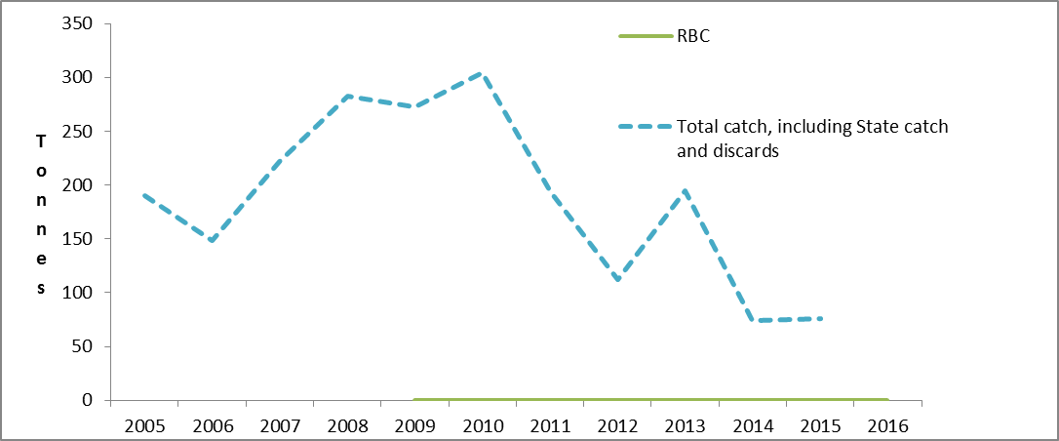
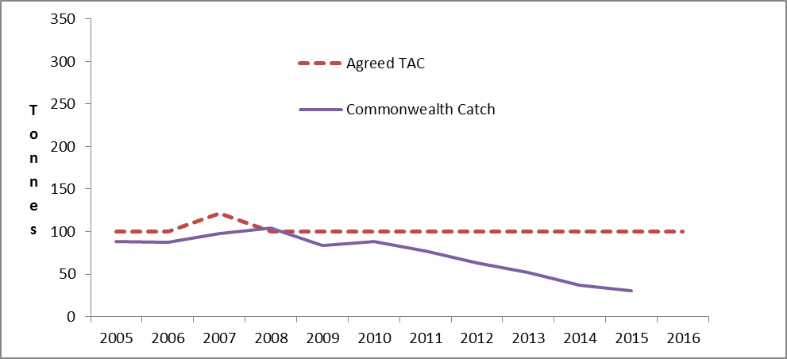

  - Western Gemfish (Rexea solandri)

ABARES (2012): Line Drawing – Shane Weidland

Obsolete common names: Hake, Common gemfish, Deepsea Kingfish, King barracouta, King couta, Silver Gemfish, Southern Kingfish
Assessed by GABRAG in 2016.

Stock status summary
Stock structure | There are considered to be two stocks of R. solandri in Australia, an eastern and a western stock bordered by a boundary in the south west of Tasmania (west of 146°22’E, north of 42°43’S).  Currently available data indicate a single biological stock of western gemfish.
Stock status against reference points and trend | Limit reference 20 per cent of unfished biomass  Target reference 48 per cent of unfished biomass  An integrated assessment model and CPUE analysis were used to estimate depletion and changes in catch rate. Both analyses identified deficiencies in the data which prevented precise estimates of stock status.
ABARES most recent assessment (2016) | Biomass: Not overfished | Fishing mortality: Not subject to overfishing
GVP figures  (2014-15 fishing season) | GVP | % fishery GVP
GVP figures  (2014-15 fishing season) | $0.1 million | 0.15%
Recommended Biological Catch 2017-18 | 200 t* (for the eastern part of the fishery that is fished by the Commonwealth Trawl Sector (CTS) (Zones 40 and 50)).  * see comments below regarding data limitations and the basis for the RBC recommendation.
Overcatch/undercatch | - 10% undercatch  - 10% overcatch
Probability of recommended biological catch (RBC) (or other levels of catch) causing a decline below limit reference under proposed management  Species that follow a HS rule that has been MSE tested will have a “very unlikely” score in this section (i.e. P<10%). | The RAG considered a Tier 1 assessment, Tier 4 assessment, and catch history in a weight of evidence approach to recommend an RBC. These indicated that there was a low risk of the stock declining below the limit reference point. Over the last five years catch and discards have remained below the RBC.
 | Alternative Catch Scenarios = N/A

TAC and catch trends
Assessment Year | 2011 | 2012 | 2013 | 2014 | 2015 | 2016
Tier /rollover /MYTAC | Tier 1 | Rollover of 2011 assessment | Tier 1 (Tier 4 used to set CTS TAC) | 2nd year of 3 year MYTAC | 3rd year of a 3 year MYTAC | Tier 1  Tier 4
Stock Status | 78% | Rollover of 2011 assessment | Tier 1 -74%  Tier 4 - CPUE between the target and limit | Not assessed | Not assessed | Tier 1 –  43%  Tier 4 (CTS) Above the limit (no discards) and above the target (discards)
Fishing Year | 2012/13 | 2013/14 | 2014/15 | 2015/16 | 2016/17 | 2017/18 (CTS area)
RBC (t) | 613 | 613 | 676 (T1)  346 (T4) | 247 (T4) | 247 (T4) | 200 (T1)  139 (T4)  423 (T4 discards)
Agreed TAC (SET only) | 141 | 199 | 199 | 183 | 247
Actual TAC after overs/unders | 147 | 211 | 217 | 200 | 261
% TAC caught | 37 | 35 | 33 | 41

Tier Level & Discounts
Tier Level | Tier 1- for details of Tiers and the Harvest Strategy, see: http://www.afma.gov.au
Discount factor | 0%
Is a multi-year TAC in place? | ☐Yes (in place this season) | ☒No
Is a multi-year TAC recommended?  (please provide a clear indication on whether the multi-year recommendation is a RBC (e.g. based on Tier 1 model output) or TAC (e.g. a roll-over of catch)) | ☒Yes  - 3 year: 200 t (RBC for Zones 40 and 50 only)  The RAG noted there were significant uncertainties with the assessments reflecting limited data availability. The RAG recommended a multi-year RBC to allow targeted data collection. | ☐No
Breakout rules for multi-year TAC | Total catch and discards (CTS) increases or decreases from the average catch over the previous five years by more than 20 per cent (e.g. 2016 catch is more than 20 per cent higher or lower than the average catch over 2011-15).  Total effort by shots (CTS) increases or decreases from the average effort over the previous five years by more than 20 per cent.  GABRAG has formed a sub-committee to review GABTS development strategy triggers for western gemfish in the SESSF Harvest Strategy Framework.
Have breakout rules been triggered? | NA

Assessment
Stock indicator trends | The RAG considered a weight of evidence approach using Tier 1 and Tier 4 assessments as well as catch history. These indicated that there was a low risk of the stock declining below the limit reference point.
RAG comments | The RAG considered a Tier 1 assessment, a Tier 4 assessment (no discards) and a Tier 4 assessment (discards). These analyses identified deficiencies in the data which prevented precise estimates of stock status being made. There were insufficient data to provide a reliable understanding of productivity of western gemfish in the GAB. Accordingly, the RAG based its advice on the CTS component of the Tier 1 assessment in the context of the outcomes of the three assessments and current catches relative to TAC.  The RAG noted that market restrictions were limiting the landed catch of western gemfish.  The RAG noted discards were high compared to landed catch and recommended AFMA engage with industry associations to develop approaches to reduce discards.
Key model technical assumptions/parameters | In relation to the Tier 4 assessment which includes discards, the RAG noted the key assumption was that no shots of western gemfish were completely discarded. If some shots were completely discarded, the Tier 4 (no discards) assessment will be biased high.  If discards are not included in the Tier 4 assessment, then it will be biased low. As such, the actual CPUE will be bounded by the Tier 4 discard CPUE and Tier 4 no discards CPUE assessments.
Changes to model structure/assumptions | The Tier 1 stock synthesis assessment model was updated (to SSv24z).  In the previous Tier 1 assessment, decisions regarding model structure and tuning were based on the views of the GABRAG and standard procedures employed in Tier 1 assessments in the SESSF. In the current Tier 1 assessment the tuning and balancing was determined from the software.
Significant changes to data inputs | N/A
Comments on data | The RAG noted that limited data availability restricted its ability to assess the stock. In particular:  - There is a paucity of length frequency data for the GAB and more recently (since 2006) for the CTS.  - There has been no biological data collected specifically for western gemfish and the assessment relies on characteristics from eastern gemfish.  - There is a need to better understand the effect of high levels of discarding on CPUE.  The RAG recommended that future data collection for western gemfish be considered by AFMA, the RAG, GABIA, SETFIA, recognising the current and likely future economic contribution of the species.
Implications for companion species/TEPs/multi-species fisheries | N/A

Tier 1 stock projection and Tier 4
Projected biomass (include confidence intervals) | 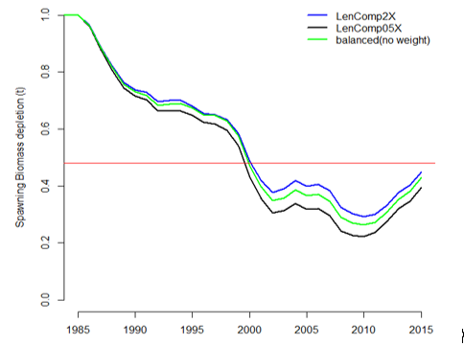  Western gemfish depletion estimates from the Tier 1 assessment (green line is the base case).  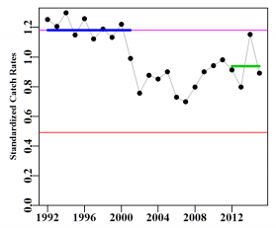  Western Gemfish (Zones 40 and 50) CPUE without the inclusion of discards with the upper thin line representing the target catch rate and the lower line representing the limit catch rate.  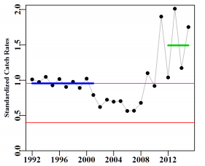  Western Gemfish (Zones 40 and 50) CPUE including discards with the upper thin line representing the target catch rate and the lower line representing the limit catch rate.

Research
Research allowance | N/A
Research allowance | ☐Included in TAC |  | ☐In addition to TAC

Catch trends
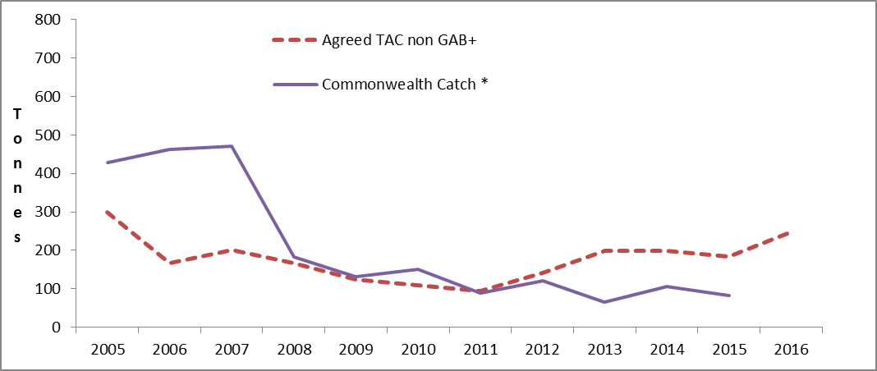

+ SET TAC, does not apply in the GABTS
* Includes both SET and GABTS landings

  - Gummy shark (Mustelus antarcticus)

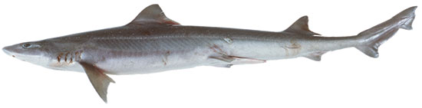
(Fisheries Research & Development Corporation, 2012)

Assessed by SharkRAG in 2016

Stock status summary
Stock structure | Gummy shark is endemic to southern Australia. It is considered a single genetic stock across the SESSF extending from Bunbury in Western Australia to Jervis Bay in NSW. The single genetic stock is assessed as three separate sub-stocks within broad regions on the continental shelf of Bass Strait, Tasmania and South Australia.
Stock status against reference points and trend | Limit reference point is 20 per cent of unfished biomass (pup production is used as a proxy for breeding biomass)  Target reference point is 48 per cent of unfished biomass (pup production is used as a proxy for breeding biomass)  The 2016 assessment estimates that each of the three sub-stocks are above the target reference point.
ABARES most recent assessment (2016) | Biomass: Not overfished | Fishing mortality: Not subject to overfishing
GVP figures (2014-15 fishing season) | GVP | % fishery GVP
GVP figures (2014-15 fishing season) | $14.6 million | 21.5 per cent

Recommended Biological Catch 2016-17 | Based on the 2016 stock assessment, the RAG recommended a three year MYTAC using either of the following RBCs, with a preference for either case 8 or 9:  - Reference case - 2080 t, 1878 t, then 1807 t  - Case 8 - The total catch for each future year is set to 1961t (the long-term RBC).  - Case 9 - The total catch for each future year is set to 1922t (the average of the RBCs over the first three years, 2016, 2017, 2018).
Overcatch/undercatch | 10 per cent undercatch  10 per cent overcatch
Probability of recommended biological catch (RBC) (or other levels of catch) causing a decline below limit reference under proposed management  Species that follow a HS rule that has been MSE tested will have a “very unlikely” score in this section (i.e. P<10%). | Very unlikely (P<10 per cent)
Alternative Catch Scenarios: The RAG considered 10 year projections where catch is taken by different gear types
(pup production as a percentage of unfished pup production).
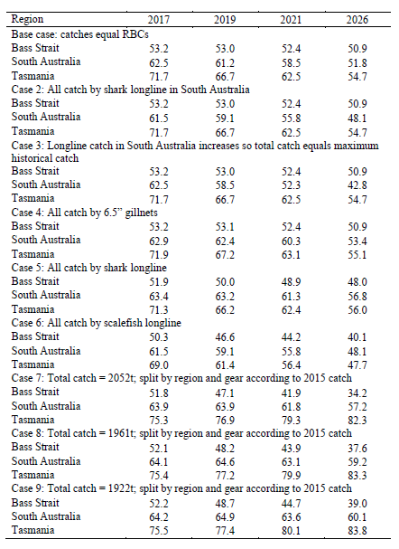
The RAG noted that even where all the RBC in South Australia (743.8 t) is taken by longline, the stock remains above target to 2026 (case 2). Even if longline catch in South Australia increased to the maximum historic catch (all gear) the stock would remain above target to 2021 (case 3).

TAC and catch trends
Assessment year | 2009 | 2010 | 2011 | 2012 | 2013 | 2014 | 2015 | 2016
Tier /rollover /MYTAC | Tier 1 | Tier 1 | Rollover | Rollover | Tier 1 | MYTAC | MYTAC | Tier 1
Stock Status | >B_{TARG} | >B_{TARG} | >B_{TARG} | >B_{TARG} | >B_{TARG} | >B_{TARG} | >B_{TARG} | >B_{TARG}
Fishing season | 2010/11 | 2011/12 | 2012/13 | 2013/14 | 2014/15 | 2015/16 | 2016/17 | 2017/18
RBC | 1800 | 1836 | 1836 | 1836 | 2010 | 2010 | 2010 | 1961
Agreed TAC* | 1717 | 1717 | 1717 | 1836 | 1836 | 1836 | 1836
Actual TAC after overs/unders | 1826 | 1847 | 1862 | 1964 | 1986 | 1978 | 1925
% TAC caught | 85 | 79 | 79 | 77 | 77 | 91

*Note that Commonwealth TAC is set based on the RBC minus state allocation. Details of the state allocation are outlined in the MOU between the Commonwealth and the State of Victoria and South Australia. The total state allocation for Gummy shark is 4.6 per cent of the global catch limit (or RBC) and is apportioned for catch in South Australian internal waters (2.9 per cent) and catch in Victorian Bays and Inlets (1.7 per cent).

Tier Level & Discounts
Tier Level | Tier 1
Discount factor | 0 per cent
Is a multi-year TAC in place? | ☐Yes (in place this season)  2016-17 was the last year of the three year MYTAC | ☐ No
Is a multi-year TAC recommended?  (please provide a clear indication on whether the multi-year recommendation is a RBC (e.g. based on Tier 1 model output) or TAC (e.g. a roll-over of catch)) | ☒Yes (recommended for future seasons)  - 3 year RBC of 1961 tonnes | ☐No
Breakout rules for multi-year TAC | SharkRAG recommended the following triggers for review of multi-year TACs:  - If annual catches in any regional sub stock exceed the long term RBC for that region (1098t in Bass Strait, 650t in South Australia or 213t in Tasmania) by more than 20 per cent.  - If gummy shark catches in the SESSF fall below 1200t.  - Standardized gillnet CPUE value for Bass Strait approaches historical lows (falls below the 10th percentile of the historical values for Bass Strait). Historical period being from 1997 to 2013 (Bass Strait is used because South Australian CPUE is no longer used in the assessment and Tasmania is in a fish down period with the stock above target).
Have breakout rules been triggered? | n/a

Assessment
Stock indicator trends | All three assessment stocks remain above target, with no evidence that stocks were ever below the management target.
RAG comments | The RAG agreed that it would have the most confidence in the reference case model RBCs, however, this would result in an increase in TAC in the first year, then a significant step down in TAC. The RAG were concerned that this could lead to higher short term catches with a potential increase in effort to the Bass Strait, followed by a large drop in TAC. The Economics Member also noted the reference case leaves the stock above the target reference point, which is not ideal from an economic perspective.  The RAG agreed that cases 8 and 9 were acceptable from a biological perspective and would be preferable to Industry from a stability perspective. It was noted that both cases assume the catch would remain at the 2015 proportions which was particularly high in the Bass Strait. The RAG emphasised that under these cases there would be short term stability for Industry, however a new assessment in 2019 would likely to result in a lower RBC following fishing down to the target reference point.  Considering the options, the RAG recommended a three year MYTAC using either case 8 or 9:
Key model technical assumptions/parameters | The model uses three management regions which are assessed simultaneously.  Differing availability to gear by age is incorporated into model reflecting the varying ability to target gummy shark. Although this approach improves fits to data, for the next gummy shark assessment, SharkRAG agreed to investigate estimating selectivity separately for each region and allowing it to be a more flexible form. This may allow the differing availability function to be removed from the assessment.
Changes to model structure/assumptions | The following changes were made to the 2013 model:  - catches by various gear types are assumed to occur simultaneously rather than sequentially  - the ‘hook fleet’ is now separated into shark longline, trawl, and scalefish longline gear types  - allowance is made for age reading error.
Significant changes to data inputs | The following data were added to the 2016 model:  - landings for the seven gear types included in the assessment  - length composition data for the seven gear types  - age composition data for 1995, 1997, 2002 and 2003  - updated catch rate data.
Comments on data | Standardized gillnet CPUE from South Australia is no longer used in the assessment.
Implications for companion species/TEPs/multi-species fisheries | The gillnet fishery interacts with Australian sea lions in waters off South Australia. Interactions are mitigated by using trigger limits that close spatial zones for 18 months if an interaction occurs.  Dolphin interactions are managed through the GHAT Dolphin Strategy which sets performance criteria for individual operators.  To reduce targeting of school shark, GHAT operators (excluding scalefish hook) must limit their school shark catch to 20 per cent of their gummy shark catches.

Tier 1 stock projection
Projected biomass | 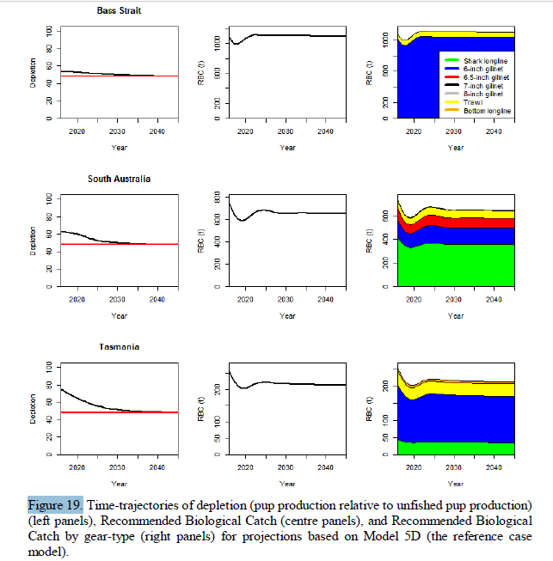

Research
Research allowance | N/A
Research allowance | ☐Included in TAC |  | ☐In addition to TAC

Catch trends – Gummy shark
(RBC and total catch are calendar year; TAC and Commonwealth catch are fishing season)
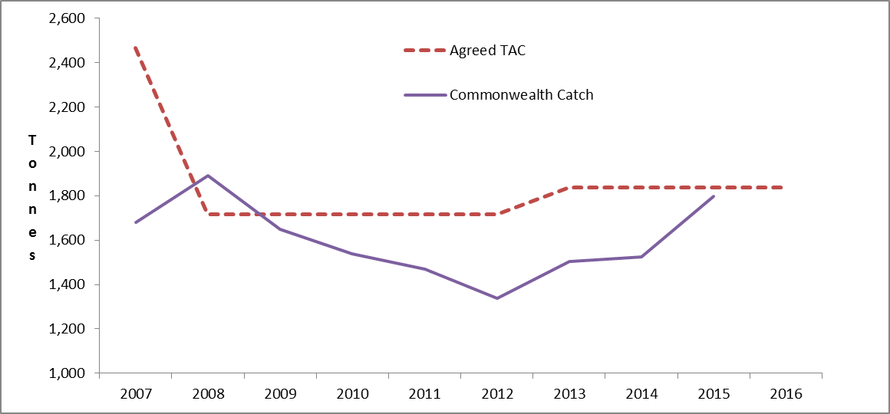

  - Mirror dory (Zenopsis nebulosus)

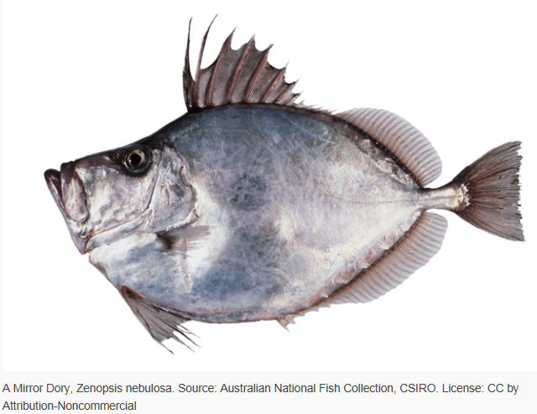

Assessed by South East RAG in 2016. Species summary updated in 2016.

Stock status summary
Stock structure | An eastern and western stock is currently assumed for assessment purposes. However mirror dory is managed under a single global TAC.
Stock status against reference points and trend | Tier 4 assessment used CPUE targets as a proxy for biomass targets.  The Tier 4 target reference point is the proxy level of CPUE assumed to produce a target biomass consistent with the harvest strategy policy, and avoid the limit reference point.  Biomass:  East  Recent CPUE-based proxy for biomass is above the limit and below the target reference point.  Trend: Standardised CPUE and catch levels have been declining.  West  Standardised CPUE is below target but above the limit reference point.
  CPUE | East | West
  Target | 1.1329 | 0.9776
  Limit | 0.472 | 0.4074
  Recent | 0.8236 | 0.7240
ABARES most recent assessment (2016) | Biomass: Not overfished | Fishing mortality: Not subject to overfishing
GVP figures  (2014 - 15 fishing season) | GVP | % fishery GVP
GVP figures  (2014 - 15 fishing season) | $0.8 million | 1.0 per cent

Recommended Biological Catch 2017- 18 | West, 104 t  East, 198 t  Total, 302 t
Overcatch/undercatch | 10 per cent undercatch  10 per cent overcatch
Probability of recommended biological catch (RBC) (or other levels of catch) causing a decline below limit reference.  Species that follow a HS rule that has been MSE tested are classified “very unlikely” in this section (i.e. P<10 per cent). | Very unlikely (P<10 per cent)
 | Alternative Catch Scenarios: N/A

 | TAC and catch trends
Assessment Year |  | 2010 | 2011 | 2012 | 2013 | 2014 | 2015 | 2016
Tier /rollover /MYTAC |  | Tier 3 | Tier 3 | Tier 3 | Tier 4 | Tier 4 | Tier 4 | Tier 4
Target |  | FSPR48 | FSPR48 | FSPR48 | East – 1.1382  West – 0.9529 | East – 1.0611  West – 0.9617 | East – 1.0195  West – 0.9644
Stock Status |  | Fishing mortality less than target | Fishing mortality less than target | Fishing mortality less than target | CPUE higher than target | East - CPUE higher than target  West – CPUE between target and limit | East - CPUE at target  West – CPUE between target and limit
Fishing Year |  | 2011/12 | 2012/13 | 2013/14 | 2014/15 | 2015/16 | 2016/17 | 2017/18
RBC |  | 906 | 7349 | 2794 | 680 | 684 | East – 362  West - 129 | East – 198  West - 104
Agreed TAC |  | 718 | 1077 | 1616 | 808 | 437 | 325
Actual TAC after overs/unders |  | 767 | 1135 | 1717 | 968 | 514 | 362
% TAC caught |  | 68 | 33 | 17 | 23 | 49

Tier Level & Discounts
Tier Level | Tier 4- for details of Tiers and the Harvest Strategy, see: http://www.afma.gov.au/
Discount factor | 15 per cent
Is a multi-year TAC in place? | ☐Yes (in place this season) | ☒No
Is a multi-year TAC recommended?  (please provide a clear indication on whether the multi-year recommendation is a RBC (e.g. based on Tier 1 model output) or TAC (e.g. a roll-over of catch)) | ☐Yes (recommended for future seasons) | ☒No
Breakout rules for multi-year TAC | N/A
Have breakout rules been triggered? | N/A

Assessment
Stock indicator trends | See below plots for standardized catch rates.
RAG comments | The Tier 4 analysis for the eastern mirror dory included discards as part of the CPUE series as agreed in 2015.  Discards are not included in the western catch rates, consequently discards do not need to be accounted for in TAC calculations.  Consistent with the 2014 and 2015 RAG advice the RAG did not recommend a MYTAC given the apparently cyclical nature of mirror dory stock status and catches, and the CPUE for East is currently declining which raises concerns that a MYTAC will not be able to respond to relatively rapid changes in biomass.

Key model technical assumptions/parameters | Standard Tier 4 assumptions apply
Changes to model structure/assumptions | N/A
Significant changes to data inputs | N/A
Comments on data | Discard estimates are historically low (since 1998) for 2015.
Implications for companion species/TEPs/multi-species fisheries

Tier 4 CPUE series
Standardized catch rates | East (including discards)  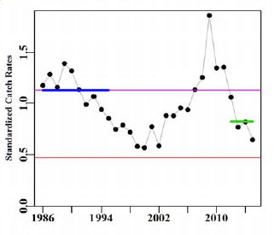  West  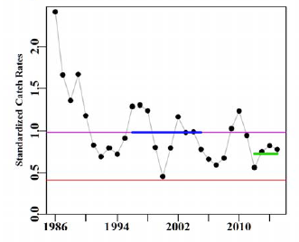  Standardized catch rates with the upper fine line representing the target catch rate and the lower line the limit catch rate. Thickened lines represents the reference period for catches, catch rates, and the recent average catch rate.

Research
Research allowance | 5 t from 2016 FIS | Research allowance

Catch trends – Mirror dory
(RBC and total catch are calendar year; TAC and Commonwealth catch are fishing season)
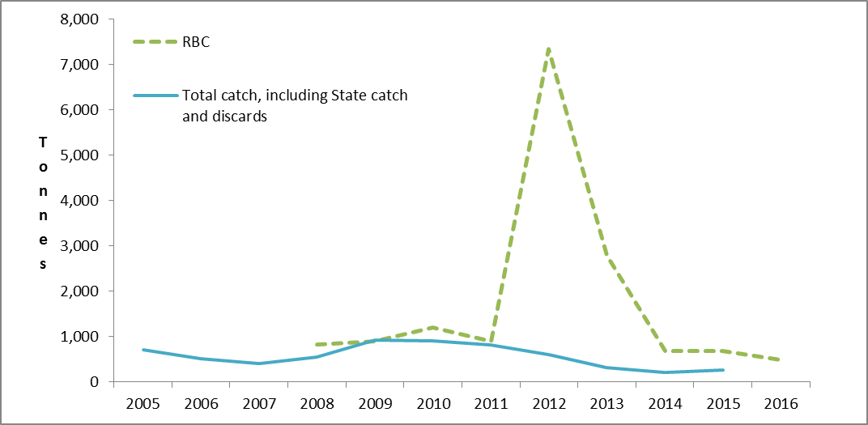
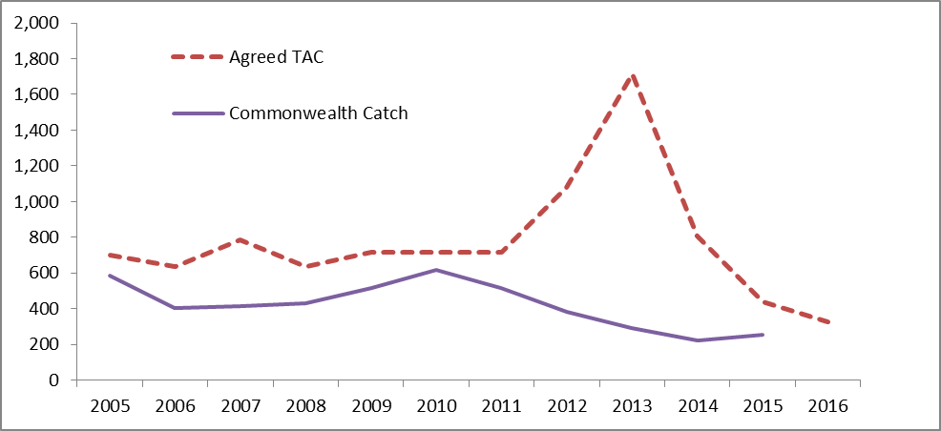

  - Redfish (Centroberyx affinis)

ABARES (2012)

Common names: Nannygai, red snapper, king snapper, golden snapper.

Last Tier 1 assessment 2014. Discussed by SERAG in 2016. Species summary updated in 2016.

Stock status summary
Stock structure | No formal stock discrimination studies have been done in Australia.  Tagging studies suggested a single unit stock of redfish off NSW. Previous studies of mean length at age suggest differences in growth rates between the ‘northern’ and ‘southern’ sectors of the fishery off eastern Australia. The boundary being Latitude 36ºS (just north of Montague Island).  Previous assessments of the redfish stock have therefore also considered that the fishery exploits two separate populations, with the boundary between these ‘stocks’.  However for the 2014 assessment, the RAG agreed to use a single stock model with no split at 36ºS.
Stock status against reference points and trend | Limit reference point is 20 per cent of unfished biomass.  Target reference point is 48 per cent of unfished biomass.  The 2014 assessment estimated that the stock is below the limit reference point at an estimated 2015 stock status of 11 per cent of unexploited levels.  The Redfish Stock Rebuilding Strategy was implemented in 2016.
ABARES most recent assessment (2016) | Biomass: Overfished |  | Fishing mortality: Uncertain
GVP figures  (2014 - 15 fishing season) |  | GVP |  | % fishery GVP
 |  | $0.2 million |  | 0.29 per cent
Recommended Biological Catch 2017-18 |  | Given there are no new data available that would inform a change of decision the RAG recommended continuing with a RBC of zero and an incidental catch TAC of 100 t.  The 100 t bycatch TAC was recommended based on the analysis that indicated catches up to 150 t would allow rebuilding in a similar timeframe to lower catches, and making allowances of 50 t for state catches and discards. This also factors in the potential for strong recruitment to enter the fishery in the next few years, and the need to avoid unnecessary discards if possible.
Overcatch/undercatch |  | NIL
Probability of recommended biological catch (RBC) (or other levels of catch) causing a decline below limit reference under proposed management  Species that follow a HS rule that has been MSE tested will have a “very unlikely” score in this section (i.e. P<10 %). |  | N/A – the stock is assessed as being below the limit reference point
 |  | Alternative Catch Scenarios: catches from between 0 t and 150 t provide for rebuilding to the limit reference point by 2019 (assuming average recruitment).

TAC and catch trends
Assessment Year | 2010 | 2011 | 2012 | 2013 | 2014 | 2015 |  | 2016
Tier /rollover /MYTAC | Tier 3 | Tier 3  Tier 4 | Tier 3  Tier 4 | Tier 3  Tier 4 | Tier 1 | Incidental TAC |  | Incidental TAC
Target | B₄₈ | B₄₈ | B₄₈ | B₄₈ | B₄₈ | B₄₈ |  | B₄₈
Stock Status | Fishing mortality less than target | Tier 3 - Fishing mortality less than target  Tier 4 – CPUE lower than limit | Tier 3 - Fishing mortality less than target  Tier 4 – CPUE lower than limit | Tier 3 - Fishing mortality less than target  Tier 4 – CPUE lower than limit | <BLIM | <BLIM |  | <BLIM
Fishing Year | 2011/12 | 2012/13 | 2013/14 | 2014/15 | 2015/16 | 2016/17 |  | 2017/18
RBC | 1985 | Tier 3 – 1569  Tier 4 – 0 | Tier 3 – 2932  Tier 4 - 0 | Tier 3 – 3791  Tier 4 - 0 | 0 | 0 |  | 0
Agreed TAC | 276 | 276 | 276 | 138 | 100 | 100
Actual TAC after overs/unders | 330 | 299 | 303 | 164 | 100 | 100
% TAC caught | 28 | 22 | 30 | 48 | 45

Tier Level & Discounts
Tier Level | A Tier 1 assessment was undertaken in 2014. For details of Tiers and the Harvest Strategy, see: http://www.afma.gov.au
Discount factor | 0 per cent
Is a multi-year TAC in place? | ☐Yes (in place this season) | ☒No
Is a multi-year TAC recommended?  (please provide a clear indication on whether the multi-year recommendation is a RBC (e.g. based on Tier 1 model output) or TAC (e.g. a roll-over of catch)) | ☐Yes (recommended for future seasons) | ☒No
Breakout rules for multi-year TAC | N/A
Have breakout rules been triggered? | N/A

Assessment
Stock indicator trends | The 2014 Tier 1 assessment estimates an increase in recruitment. This was supported by preliminary results from the 2014 Fishery Independent Survey which show an increase in catch of smaller fish.
RAG comments | With regards to the 2014 Tier 1, the RAG noted:  - the model was heavily influenced by declining catch rates  - changes to gear (a bigger diamond mesh) should be considered to reduce the bycatch of juvenile redfish. However, the RAG noted that this may impact on the catches of other highly desirable species such as flathead  - existing closed areas may provide some degree of protection for redfish however this has not been quantified  - avoiding redfish is difficult because they are evenly spread around the fishery.  - sensitivities explored by re-running the model with a wide range of different input parameters produced depletion estimates in the range of 7–19 per cent of B₀.  Comments from the 2016 SERAG meeting:  - There is no evidence of range contraction.  - Fishing mortality is unlikely to be the driver for slow recovery.  - Recruitment has been below average for several years.
Key model technical assumptions/parameters | Stock Synthesis software is used for this Tier 1 assessment  M natural mortality is fixed at 0.1  Beverton-Holt type recruitment is assumed with a steepness of 0.75  Growth function is estimated by the model separately for females and males.
Changes to model structure/assumptions | N/A – first Tier 1 assessment
Significant changes to data inputs | N/A – first Tier 1 assessment since the SESSF Harvest Strategy Framework was introduced
Comments on data
Implications for companion species/TEPs/multi-species fisheries | Companion species analysis indicates that the majority (64 per cent) of all redfish are taken in shots where redfish is not the most valuable component of the catch. This suggests it is not normally targeted.  Flathead is the species most commonly being targeted when redfish are caught (31 per cent).  The last companion species analysis (Klaer, 2010) indicated that of 156 t of redfish caught, 100 t was caught in shots where redfish was not main species taken.  In the 2015 fishing season, 50 t of redfish was landed while 3095 t of flathead was landed, suggesting that full quota utilisation of flathead does not result in substantial redfish mortality (total redfish discards in 2015 was 74 t).  Projections completed in the 2014 redfish stock assessment showed that redfish would rebuild by 2018 or 2019 at catches of 0 t, 50 t, 100 t and 150 t (i.e. catches up to 150 t made little different to the projected rebuilding rate for redfish).

Tier 1 stock projections
Projected biomass (include confidence intervals) | 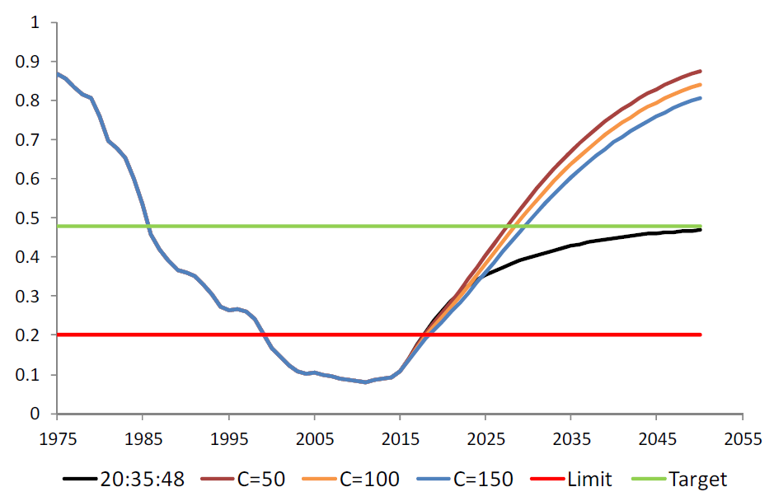  The accepted base case suggests that redfish will rebuild to the limit reference point within four years however this is under zero catches and average recruitment (Tuck 2014).

Research
Research allowance | 0 t
Research allowance | ☐Included in TAC |  | ☐In addition to TAC

Catch trends – Redfish
(RBC and total catch are calendar year; TAC and Commonwealth catch are fishing season)
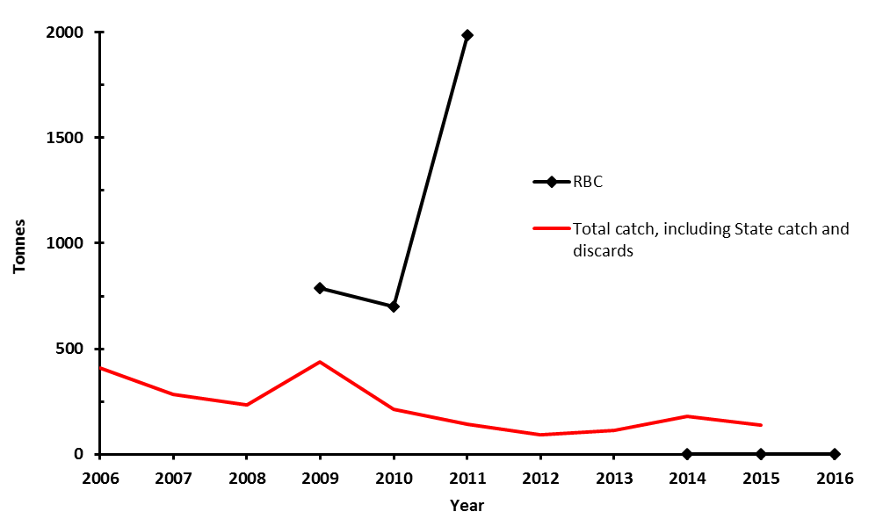
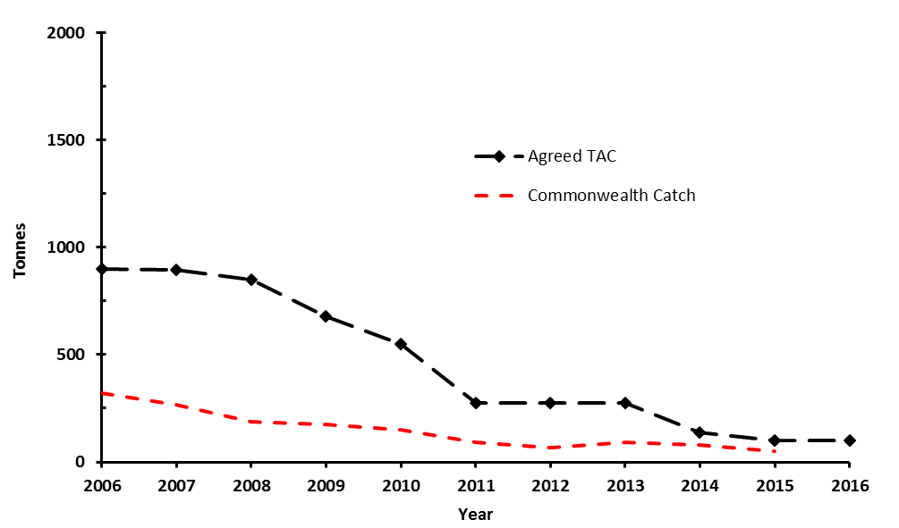

Due to conflicting assessments no RBC was set for 2012 or 2013.

  - School shark (Galeorhinus galeus)

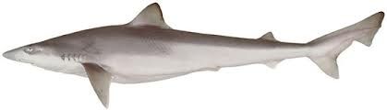
(Fisheries Research & Development Corporation, 2012)

Under a Stock Rebuilding Strategy.
Assessed by SharkRAG in 2009. Species summary updated in 2016.

Stock status summary
Stock structure | The assessment model assumes that there is one well mixed stock.  Tagging and genetic data shows some evidence for one well mixed stock. However, earlier data suggests there could be an east/west divide in stocks. This is supported by research documenting a collapse in the eastern part of the fishery around Tasmania and Bass Strait. After this collapse a fishery subsequently established in the west suggesting a reproductively isolated stock.
Stock status against reference points and trend | Target reference point is 48 per cent of the unfished biomass (pup production is used as a proxy for breeding biomass).  Limit reference point is 20 per cent of the unfished biomass ₍pup production is used as a proxy for breeding biomass).  In 2016 SharkRAG noted trawl standardised CPUE, although representing a small amount of catch, continues to show a sustained increase.  In 2015 the RAG noted the stock was assessed at below the limit reference point. However the RAG considered that the weight of evidence supported that the stock is rebuilding and not subject to overfishing within the rebuilding time of three generation times.
ABARES most recent assessment (2015) | Biomass: Overfished | Fishing mortality: Uncertain
GVP figures (2014 - 15 fishing season) | GVP |  | % fishery GVP
GVP figures (2014 - 15 fishing season) | $1.7 million |  | 2.5 per cent
Recommended Biological Catch 2017-18 | - 0 t. No targeted fishing as stock is < B_{LIM}  - Commonwealth TAC recommendation is 215 t. The TAC is set at the lowest level to cover unavoidable bycatch whilst still supporting rebuilding of the stock.
Overcatch/undercatch | - 0 per cent undercatch  - 0 per cent overcatch
Probability of recommended biological catch (RBC) (or other levels of catch) causing a decline below limit reference under proposed management  Species that follow a HS rule that has been MSE tested will have a “very unlikely” score in this section (i.e. P<10 %). | RBC recommendation: N/A as currently assessed at below the limit reference point.
Alternative Catch Scenarios:
Table 1. Number of years after 2008 when the school shark stock is predicted to achieve limit (B₂₀, B₂₅) or target reference points (B₄₀, B₅₀) under future catches ranging between 0 and 275t. Results are shown for the assumption that the distribution of fishing effort in the future matches that if either 2011, or 2008.

 | 0t | 100t | 125t | 150t | 175t | 200t | 225t | 250t | 275t
2009 Base Case – 2011 proportions
B₂₀ | 23 | 30 | 32 | 36 | 40 | 47 | 58 | 80 | -
B₂₅ | 30 | 38 | 42 | 46 | 51 | 59 | 71 | 95 | -
B₄₀ | 45 | 57 | 62 | 67 | 74 | 83 | 97 | 124 | -
B₅₀ | 50 | 62 | 67 | 73 | 80 | 89 | 104 | 132 | -
2009 Base Case – 2008 proportions
B₂₀ | 23 | 30 | 33 | 37 | 42 | 50 | 64 | 99 | -
B₂₅ | 30 | 39 | 42 | 47 | 53 | 63 | 78 | 117 | -
B₄₀ | 45 | 58 | 63 | 69 | 76 | 87 | 105 | 150 | -
B₅₀ | 50 | 63 | 68 | 74 | 82 | 93 | 111 | 159 | -

Assessment Year | 2010 | 2011 | 2012 | 2013 | 2014 | 2015 | 2016
Tier /rollover /MYTAC | rollover | rollover | rollover | rollover | rollover | rollover | rollover
Stock Status | <B_{LIM} | <B_{LIM} | <B_{LIM} | <B_{LIM} | <B_{LIM} | <B_{LIM} | <B_{LIM}
Fishing season | 2011/12 | 2012/13 | 2013/14 | 2014/15 | 2015/16 | 2016-17 | 2017-18
RBC | 0 | 0 | 0 | 0 | 0 | 0 | 0
Agreed TAC | 176 | 150 | 215 | 215 | 215 | 215
Actual TAC after overs/unders | 176 | 150 | 214 | 215 | 215 | 215
% TAC caught | 92 | 85 | 90 | 94 | 84

Tier Level & Discounts
Tier Level | Tier 1
Discount factor | 0 per cent
Is a multi-year TAC in place? | ☐Yes (in place this season) | ☒No
Is a multi-year TAC recommended?  (please provide a clear indication on whether the multi-year recommendation is a RBC (e.g. based on Tier 1 model output) or TAC (e.g. a roll-over of catch)) | ☐Yes (recommended for future seasons)  N/A | ☒No
Breakout rules for multi-year TAC | N/A
Have breakout rules been triggered? | N/A

Assessment
Stock indicator trends | Gillnet CPUE is not considered a reliable index of abundance as school shark are actively avoided by gillnet fishers.  In 2016 SharkRAG noted that there are continuing positive signs suggesting that the school shark is rebuilding. This is based on an overall increasing trend in trawl CPUE (since 2003). This is consistent with advice from industry that school shark, particularly juveniles, are in relatively high abundance.  Figure below. School shark standardised CPUE and FIS abundance.  A close kin genetics project is in progress to develop alternative and independent measures of abundance for the stock. An estimate of abundance is expected by the end of 2017 with a stock assessment to follow shortly after.
RAG comments | Assessments (since 1991) have consistently estimated the school shark population to be below the limit reference point of 20 per cent of unfished levels.  The RAG noted that the number of large shots (greater than 250 kilograms) of school shark in 2015 had decreased. The RAG noted that the number of shots above 250 kilograms in 2014 was high and suggested that this be reviewed by AFMA.  While catch by boat data over the last five years did not raise specific concerns about targeting, the RAG recommended that AFMA investigate two boats that appeared in four of the five years (although this may reflect higher effort).  The RAG noted that range did not appear to be contracting and catch plus discards was below the incidental bycatch TAC level of 215 tonnes in 2015.  SharkRAG recommended school shark catches in 2016/17 be restricted to a level that covers unavoidable bycatch and discards. SharkRAG considers 215 t continues to be the best estimate of unavoidable bycatch including discards.
Key model technical assumptions/parameters | The assessment model assumes that there is one well mixed stock.
Changes to model structure/assumptions | The stock’s intrinsic rate of productivity, held fixed at 3.5 per cent since the 2006 stock assessment update, was estimated by the model during 2012, using (but not updating) the 2009 stock assessment model. The new runs of the model showed that a productivity value of 4.4 per cent is more consistent with the available data.
Significant changes to data inputs | N/A
Comments on data | The RAG had concerns that length frequency data were not currently being collected as part of the data collection programme for the GHAT with the introduction of electronic monitoring.  There are concerns in relation to gillnet CPUE data used in the model due to operators avoiding school shark. As a result, concern remains about the ability of the school shark assessment to reliably estimate the state of the stock. A close kin project is underway and is expected to provide a measure of abundance in 2017.
Implications for companion species/TEPs/multi-species fisheries | The gillnet fishery interacts with Australian sea lions in waters off South Australia. Interactions are mitigated by using trigger limits that close spatial zones for 18 months if an interaction occurs.  Dolphin interactions are managed through the GHAT Dolphin Strategy which sets performance criteria for individual operators.  To reduce targeting, gillnet operators are subject to a rule that constrains their catches of school shark to 20 per cent of their gummy shark catches.

Tier 1 stock projection
Projected biomass (include confidence intervals) | Figure 1. Projected future depletion from 2012 stock assessment re-run (pup production divided by pristine pup production) for the school shark stock for the Tier 1 2009 base case assessment model. Projections are shown for 9 future catch scenarios. Catches between 2008 (marked by a vertical line) and 2011 are the actual catches taken by the fishery.

Research
Research allowance | N/A
Research allowance | ☐Included in TAC |  | ☐In addition to TAC

Catch trends – School shark
(RBC and total catch are calendar year; TAC and Commonwealth catch are fishing season)

Glossary
Biological reference points – quantitative values, often stated in terms of fishing mortality or stock size, that summarise either a desired state for the stock (a target) or a state of the stock that should be avoided (a threshold).
Biomass – the total weight of all the fish in a stock or a component of a stock.
B_{LIM} (biomass limit reference point) – the point beyond which the risk to the stock is regarded as unacceptably high.
B_{MEY} (biomass at maximum economic yield) – average biomass corresponding to maximum economic yield.
B_{MSY} (biomass at maximum sustainable yield) – average biomass corresponding to maximum sustainable yield.
B_{TARG} (target biomass) – the desired biomass of the stock.
B₀ (mean equilibrium unfished biomass) – average biomass level if fishing had not occurred.
Catch-per-unit effort (CPUE) – the number or biomass of fish caught as by a unit of fishing effort. Often used as a measure of fish abundance.
C_{TARG} (Catch target) – the target catch level.
CE_{LIM} (CPUE limit reference point) – the point below which CPUE is too low and can indicate stock depletion.
CE_{TARG} (CPUE target) – the target CPUE rate.
Confidence interval – also called the confidence bound, a range of values within which the true value most likely lies.
F (fishing mortality) – the instantaneous rate of fish deaths due to fishing a designated component of the fish stock.
F_{LIM} (fishing mortality limit reference point) – the point above which the removal rate from the stock is too high.
F_{MEY} (fishing mortality at maximum economic yield) – the fishing mortality rate that corresponds to maximum economic yield.
F_{MSY} (fishing mortality maximum sustainable yield) – the fishing mortality rate that achieves maximum sustainable yield.
F_{TARG} (fishing mortality target) – the target fishing mortality target rate.
Index of abundance – numerical value used to demonstrate the trend in relative abundance over time.
Markov Chain Monte Carlo (MCMC) – an approach to estimate uncertainty in a statistical model by beginning with a final model and shifting its associated parameter values slightly to recalculate the model’s goodness of fit thousands or millions of times.
Maximum economic yield (MEY) – the sustainable catch level for a commercial fishery that allows net economic returns to be maximised. For most practical discount rates and fishing costs, MEY implies that the equilibrium stock of fish is larger than that associated with maximum sustainable yield (MSY). In this sense, MEY is more environmentally conservative than MSY and should, in principle, help protect the fishery from unfavourable environmental impacts that could diminish the fish population.
Maximum sustainable yield (MSY) – the maximum average annual catch that can be removed from a stock over an indefinite period under prevailing environmental conditions.
Mortality – deaths from all causes (usually expressed as a rate or as the proportion of the stock dying each year).
Overfished – a fish stock with a biomass below the biomass limit reference point. ‘Not overfished’ implies that the stock is not below the threshold.
Overfishing, subject to – a stock that is experiencing too much fishing, and the removal rate from the stock is unsustainable. Also:
- Fishing mortality (F) exceeds the limit reference point (F_{LIM}). When stock levels are at or above B_{MSY}, F_{MSY} will be the default level for F_{LIM}.
- Fishing mortality in excess of F_{LIM} will not be defined as overfishing if a formal ‘fish down’ or similar strategy is in place for a stock and the stock remains above the target level (B_{TARG}).
- When the stock is less than B_{MSY} but greater than B_{LIM}, F_{LIM} will decrease in proportion to the level of biomass relative to B_{MSY}.
- At these stock levels, fishing mortality in excess of the target reference point (F_{TARG}) but less than F_{LIM} may also be defined as overfishing, depending on the harvest strategy in place and/or recent trends in biomass levels.
- Any fishing mortality will be defined as overfishing if the stock level is below B_{LIM}, unless fishing mortality is below the level that will allow the stock to recover within a period of 10 years plus one mean generation or three times the mean generation time, whichever is less.
Spawning stock biomass (SB) – the total weight of all adult (reproductively mature) individuals in a population. Also called spawning biomass.
SB_{MSY} – Spawning or ‘adult’ equilibrium biomass at maximum sustainable yield.
Stock assessment – an evaluation of the past, present and future status of the stock that includes a range of life history characteristics for a species, such as the geographical boundaries of the population and the stock; information on age, growth, natural mortality, sexual maturity and reproduction, feeding habits and habitat preferences; and the fisheries pressures affecting the species.

